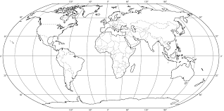
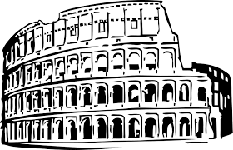
CCAP
World History
Mariposa County High School
Mrs. Bobman
2019-2020
Course Expectations

Course Design: World History is a two-semester course. The course will cover the time periods from the Ancient Civilizations to the present. Students will discover and learn about these historical periods, events, places and people through lectures, note-taking, reading, multi-media, activities, debates and special projects.

Classroom Rules- Each student in World History is expected to come to class prepared to learn, ready to follow instructions, and to be respectful toward everyone in the classroom. Do not wear hats, sunglasses, or headphones in the classroom. All cell phones and electronic devices must be turned off unless directed by the teacher. Be respectful of your environment and be sure you are not leaving a mess behind. Students are expected to remain in their assigned seat unless instructed otherwise by the teacher.
Materials/Resources- Students are expected to bring their Chromebook, notebook and a writing utensil each day. Students will check out a textbook to be used for homework.
Assignments- All assignments must have a heading (name, subject, period and date) in the upper right hand corner of the paper. Any late assignments may result in partial credit of the graded score.
Attendance- Is very important for success in the course. If a student is absent, it is the student’s responsibility to make-up the assignment. For each excused absence the student has the number of days plus one to make up any missing assignments.
Tardies- Students are expected to be in their desk before the tardy bell rings. The School policy is as follows:
1st^{t} and 2nd Tardy-Warning from teacher
3rd Tardy - Parent Notification from Teacher
4th Tardy - 1 detention/parent notification
5th Tardy - 2 detentions/parent notification
Subsequent Tardies - Conference with assistant principal, additional detention and/or suspension
Habitually Tardy - Behavior contract and/ or recommendation to Student Attendance Review Board (SARB)

Bathroom/Hall passes- Please attend to the bathroom before class. Students must ask and sign out before leaving.

Cell phones and other devices
Use of cell phones and other devices is at the discretion of the teacher. If a student uses their device in an inappropriate manner or at an inappropriate time, device may be confiscated and further disciplinary action may be taken.

Grading Scale
A: 100-90%
B: 89-80%
C: 79-70%
D: 69-60%
F: 59-0%

Grade Categories
Participation 20%
Class work/Homework 50%
Research 10%
Tests/quizzes 20%

Tips for success- Attend school every day. Follow classroom rules. Turn in complete and neat assignments. Study regularly and you must read the textbook.
Contact Information-
Stephanie Bobman sbobman@mcusd.org 209-742-0260

Name______________________
Date______________
Class_____________
CCAP
World History
Mariposa County High School
Mrs. Bobman
2019-2020
Course Expectations

I have read the student guide and agree to follow it to my best ability.

Student Signature _________________________________

I have read the student guide and course information.
Parent/Guardian Signature _________________________________

